**A2 – Ami Zou**

Once you've finished implementing and testing your scheme, upload your code to a GitHub

repository. Submit a link to your repo along with a 1-page write-up answering the following questions about your scheme.

Github repo link: <https://github.com/ami-zou/COMP590-A2>

**1. What scheme or schemes did you try? If you came up your own idea, describe it here.**

…

**2. Why do you think your scheme would do a good job predicting pixel values? How does your scheme exploit temporal and/or spatial coherence?**

…

**3. When applying the English text-based models (static, adaptive, and context-adaptive) to the video data, which scheme performed best?**

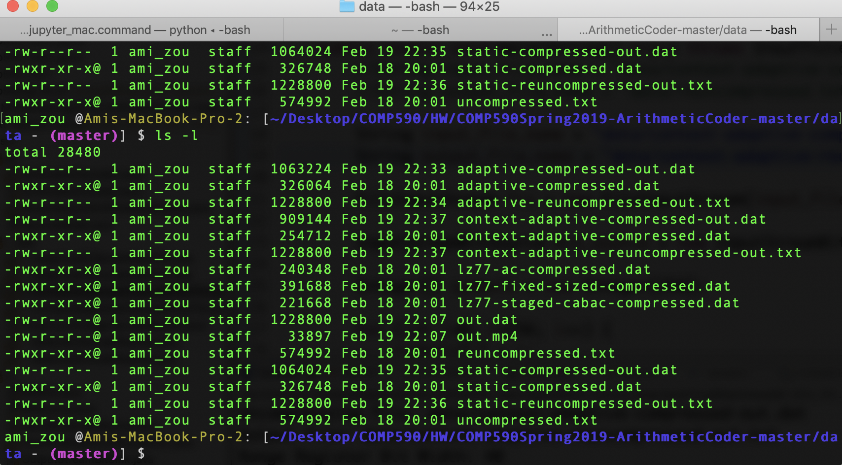

Here is a screenshot of all the compressed and uncompressed video data of “out.dat” using the three models:

* Static: 1,064,024 bytes
* Adaptive: 1,063,224 bytes
* Context-adaptive: 909, 144 bytes

As we can see, context-adaptive arithmetic encoding provides a much better compression.

**Does the scheme you developed compress better or worse than the English text-based models when applied to video data?**

…

**If you weren't able to finish and test your own scheme, how do you think your scheme would fare in comparison to the English text-based models?**

…

**4. What is one change you could make to your scheme that might improve its results?**

…